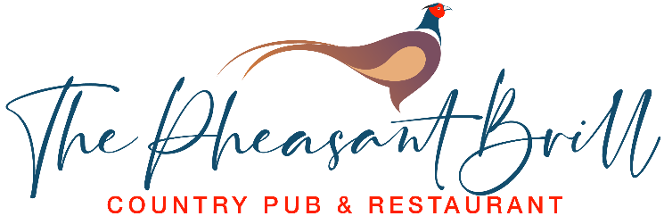
Starters
Soup of the Day £8
Grilled Halloumi, Sweet Chilli Sauce £8 V GF
Pan Fried Mushrooms, Garlic & White Wine £8 V
Mozzarella & Tomato Bruschetta £8 V
Smoked Salmon & Prawn Cornets,
Marie Rose Sauce £8
Pub Favourites
South Indian Garlic Chilli Chicken Curry, Rice,
Flat Bread & Salad £16 GF DF
Bangers & Mash, Onion Rings & Gravy £16
Double smashed Patty Burger, Bacon, Cheese, Burger Sauce & Fries £15
From the Sea
Beer Battered Haddock & Chips, Garden Peas,
Tartar Sauce £16 GF DF
Prawn Puri – Curried Prawns, Flat Bread &
Spicy Onion Salad £18 GF
“Posh Scampi” – Battered Tiger Prawns, Fries & Sweet Chilli Sauce £18
Steak Frites
10oz Sirloin Steak, Fries, Salad &
Peppercorn Sauce £25 GF

Pasta
Spaghetti Con Fungi £16 DF
Smoked Salmon Spaghettini, Garlic, White Wine, Cream & Garden Peas £18
Vegetarian
Three Cheese Omelette, Salad & Fries £16 GF
Vegetable Curry, Rice & Flat Bread £16 DF VG
Spaghetti con Fungi £16 DF
Side Orders
French Fries ● Hand Cooked Chips ● Mixed Veg Onion Rings ● Mixed Salad
£3.50 per side order
Desserts
Mississippi Mud Pie, Vanilla Ice Cream £8
Sticky Toffee Pudding, Vanilla Ice & Toffee Sauce £8
Brownie & Vanilla Ice Cream
Affogato - Vanilla Ice Cream Topped with a Double Espresso £5
Ice Creams £2 per Scoop
Vanilla ● Strawberry

